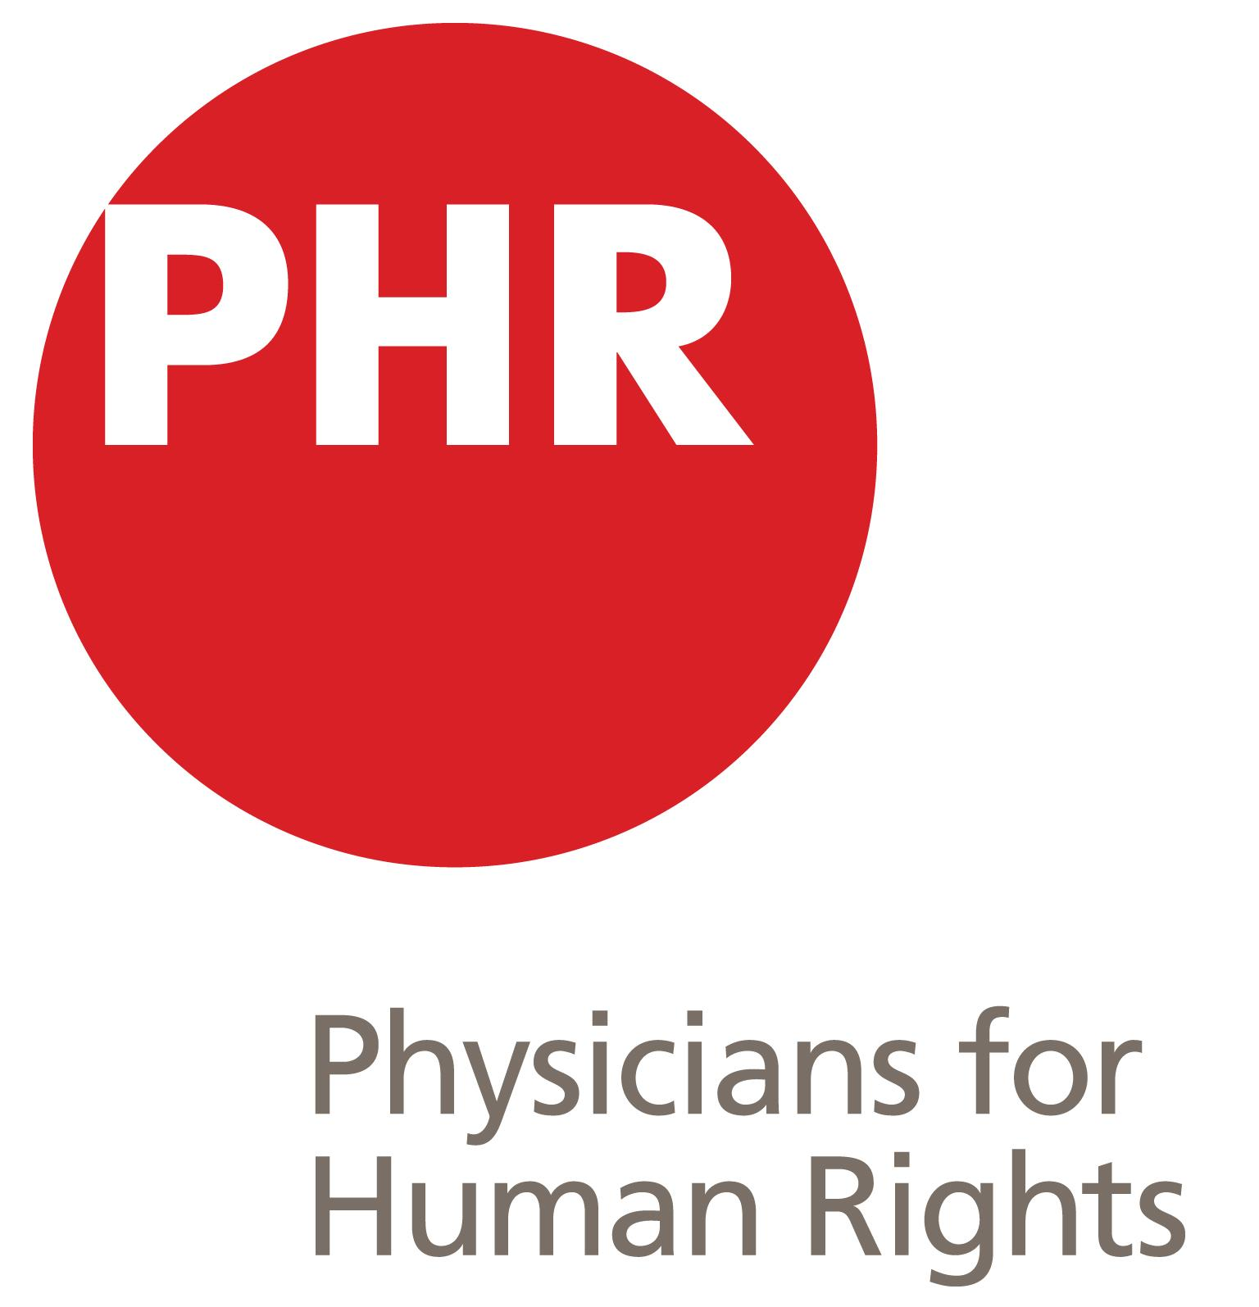
Student Advisory Board
Committee Application
2019-2020

OVERVIEW
The Physicians for Human Rights Student Advisory Board (SAB) is a group of medical students charged with coordinating and overseeing the PHR Student Program, which comprises PHR student chapters at institutions across the nation and world. By coordinating among PHR student chapters and the PHR national office, the SAB aims to strengthen and grow a national student movement that furthers PHR’s goals as well as medical students’ training in human rights.

Student Advisory Board members are expected to be self-starters and motivated individuals invested in developing and strengthening the PHR Student Program. Members of the SAB are expected to excel in oral and written communication, time management, and teamwork; they should also be motivated to continue to grow in these areas throughout their time on the SAB.

The average time expectation for SAB committee members is 8-10 hours per month, with peak activity at the beginning of the fall semester. SAB members may be rising second, third or fourth year medical students. Key responsibilities for SAB members include:
- Attend the SAB annual retreat in late summer (generally on a Saturday at PHR headquarters in NYC)
- Participate in regular SAB conference calls (generally 1-2/month).
- Engage responsively in email correspondence for SAB business
- Attend and assist in execution of the National PHR Student Conference (generally in late October/early November)

AVAILABLE POSITIONS
Regional Chapter Mentors (4 positions)
- Act as direct point of communication with student chapter leaders
- Creatively build the PHR chapter network by generating enthusiasm through innovative national outreach
- Spearhead new chapter on-boarding
- Gather and organize chapter leadership contact information and chapter event summaries
- Advise chapter leaders on how to establish, maintain, and run a PHR chapter

Advocacy Committee (3 positions)
- Design, build and promote national advocacy initiatives in line with PHR National advocacy goals
- Support PHR National advocacy campaigns
- Create complete, media-ready ‘toolkits’ for specific advocacy issues to empower medical students to speak up and act
- Develop training, educational, and service opportunities for students in conjunction with national organization efforts

Asylum & Refugee Committee (3 positions)
- Report and liaise with PHR National staff on asylum issues
- Communicate with PHR Asylum Coordinators and facilitate contact between student asylum clinics
- Serve as point-of-contact for PHR chapters on initiating and running student clinics
- Maintain regular contact among all PHR Asylum Clinics
- Assist PHR Asylum Clinics’ contact with local refugee organizations to create sustainable solutions to the migrant crisis

Media Committee (1-2 positions)
- Maintain, build and promote all of the PHR Student media platforms, including the website, Facebook, Twitter and Instagram
- Advertise PHR National efforts, campaigns, and news in real time
- Think creatively to build the PHR student presence across media platforms

Conference Committee (3 positions –two positions filled by host institution)
- Organize and plan the annual student national student conference
- Engage students from across the country to attend and support the national student conference
- Participate in selection of subsequent conference location and onboarding of host institution’s conference team

APPLICATION
The purpose of this application is to enable the selection committee (current and incoming PHR SAB Co-Chairs) to get to know you. This application must be submitted to phr.sab@gmail.com no later than Monday, March 18, 2019.

- General Information
First Name: Last Name:

Medical School: Degree Program: Grad year:

Email Address: Phone Number:

- Positions for which you would like to be considered (select as many or as few as interest you):
[ ] Regional Chapter Mentor [ ] Conference Committee
[ ] Advocacy Committee [ ] Media Committee
[ ] Asylum and Refugee Committee

- Please include the name and contact information of one peer reference.
We may contact your reference via e-mail or phone. This should be someone who has worked with you in the past.
Name of Reference:
Email: Phone number:

Relationship with reference (e.g., “worked on a project together”):

- Please submit a CV and answers to the following questions (short paragraphs):
- Why would you like to be part of the PHR Student Advisory Board?
- Please describe the skills and knowledge you would bring to the Board.
- Are you currently an active member of your school’s PHR chapter? If so, please describe for how long and in what capacity you have been involved in your chapter.
- Please describe any particular areas of interest within PHR’s current work or human rights issues.

